The algorithm should be run at the new patient meeting on thursday to include new patients in the coming week. It also include current existing patient in the pool.

If the patient at the visit in the coming week agrees to the prelimarily allocated slot from the prior thusruday new patient meeting, then that slot is allocated to that patient at the time of the visit. Pre-screen begins. The patient and the slot are out of the matching pool.

If that patient then fails pre-screening then he reenters matching pool with a waiting weight in the algorithm to recognize his earlier entry for clinical trials. Notice that there is no patient queue but only “Interested Patients.” Here is the explanation:

A patient sits in the interest list for all three trials simultaneously. That's set membership, not a place in line, and it costs nothing to be in three sets at once. At the Thursday solve they are one row in the cost matrix with finite costs against all three trials, and the algorithm's constraint is that a row gets exactly one assignment. So the patient is never "waiting in line for X and then moving to Y's line" — they are evaluated against all three trials in the same solve, every cycle.
Disqualification just blocks a cell. Their Trial X entry becomes infinite; the #2 and #3 entries keep the costs they always had. Nothing about their standing at Y changes, because their standing at Y was never a function of when they got there.
Why option (b) would actively hurt you. If patients held reserved positions at their second and third choices, those positions become encumbered capacity that isn't real. Five patients ranking X first and Y second would make Y look five deep when four of them will land at X. A coordinator reading Y's queue sees phantom demand, and any capacity planning built on it is wrong.

If the patient withdrawn from prescreening or screening on his own accord, then he does not get a waiting in the algorithm. His

SphinxMatch — How the Allocation Engine Is Applied
Frank Tsai, MD | For: Michael Gordon, MD; Khang Le | July 29, 2026 | Draft for discussion, not a build authorization
The engine does not choose trials for patients. Physicians and patients do that in the Trial Options tab. The engine resolves competition for scarce slots among patients who have already chosen, and produces a defensible record of how that competition was resolved. Part 1 is the reasoning, Part 2 the specification, Part 3 what remains open.

1 Why the engine exists

1.1 It earns its keep only under contention. Solving one patient at a time would make the optimizer decorative — the physician ranks a trial first, we assign it, nothing is optimized. The assignment problem only has teeth when several patients compete for finite capacity at the same protocol. The physician entering a Snapshot cannot see that another physician’s patient is competing for the last slot; that cross-patient view is what SphinxMatch contributes. Positioning: at a site with abundant slots and low accrual the engine is largely dormant and SphinxMatch is a matching and documentation system.

1.2 Flat weights break the solve. If all three ranked choices carry equal value the solver receives a degenerate cost matrix — large blocks of ties, every matching optimal, the result decided by row order. Patient A gets their first choice and Patient B their third for no articulable reason, which is indefensible at the New Patient meeting or to a compliance reviewer. Differentiated weights convert "the solver picked it" into "this assignment minimized aggregate preference loss, and here is the ledger." Rank alone is not enough: treating every gap as equal lets the solver trade A’s drop from a biomarker-matched targeted therapy to an unmatched dose-escalation cohort against B’s move between two near-equivalent options. But free-form utilities are gameable — 100 / 99 / 98 makes a patient look inflexible and beats an honest 100 / 50 / 20. Proposed: a fixed rank-to-weight map plus a hard-constraint flag for genuine non-substitutability.

1.3 Allocation is not a clinical decision. The engine allocates slots; it never assigns treatment. Every deviation from a physician’s first choice surfaces as a reviewable exception with the trade-off attached, never as a completed action. An engine that appeared to reassign patients would fail IRB review and lose physician adoption on first contact.

2 Workflow

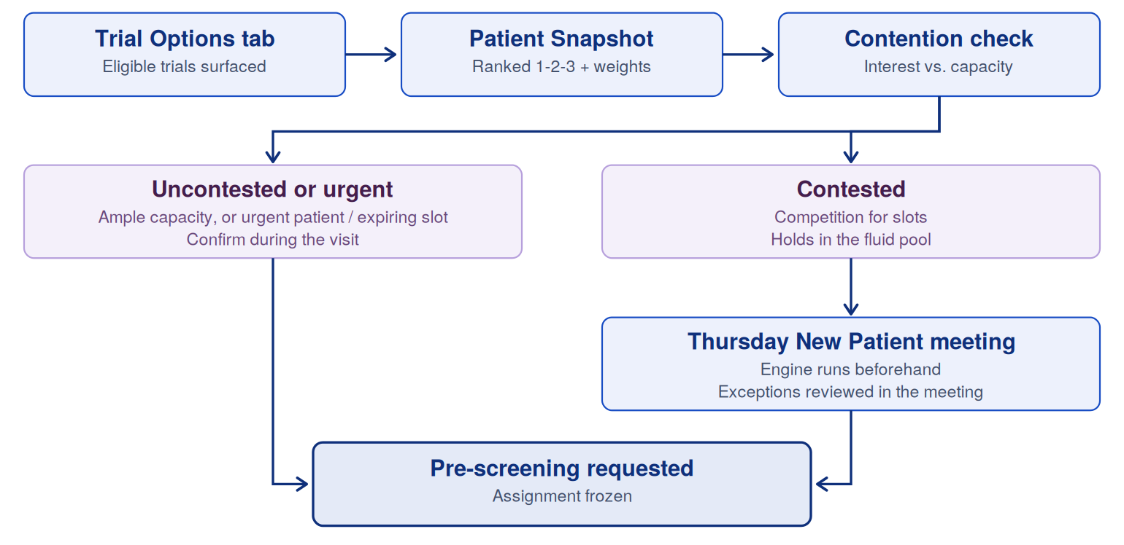

Figure 1. Allocation path from Trial Options through to a frozen assignment.

2.1 Two states. Fluid — preferences declared in the Snapshot, pre-screening not yet requested; the engine may move this patient. Frozen — pre-screening requested; the patient is out of the pool, their slot is out of available capacity, and no reallocation logic touches them. Each run operates over the fluid set against total capacity minus frozen commitments. This is the system’s most important invariant.

2.2 Triage at Snapshot entry. Contention is detectable without running the engine, since interest count versus remaining capacity is known at entry. Three lanes:
- Uncontested or urgent — capacity comfortably exceeds interest, or the patient or slot carries urgency (rapid progression, expiring slot, trial closing enrollment). Confirm in the room.
- Contested — competition exists; the patient holds in the fluid pool and is confirmed Thursday.
- Off-cycle urgent — same-day resolution required. Off-cycle run or coordinator override.
Auto-confirming uncontested patients freezes them immediately, even if later entrants would have made that assignment suboptimal. We trade a little optimality for the ability to answer in the room — the right trade in oncology. The threshold should be site-configurable.
2.3 What to tell the patient: discuss trials by name, but do not promise an assignment. Ranked choices require a substantive conversation about each candidate trial — that conversation is the input to the Snapshot, not something to avoid. "Trial X is my first choice for you, and we are confirming slot availability" is accurate and safe. "You will probably be on Trial X" is not: a Thursday call naming a different trial then reads as a reversal rather than an expected step. Where the alternatives are not real substitutes, use the hard-constraint flag rather than relying on framing.
2.4 Cadence. The engine runs Thursday morning, before the New Patient meeting, so allocations are ready for review and can be confirmed in real time. Continuous first-come-first-served was rejected: whichever coordinator moves fastest wins the slot, and nothing is optimized. Re-running on every pool change was also rejected: a provisional allocation flipping mid-week means telling a physician two different things. Off-cycle runs only when capacity itself changes, or for same-day urgent cases.

3 Interest lists and backfill queues

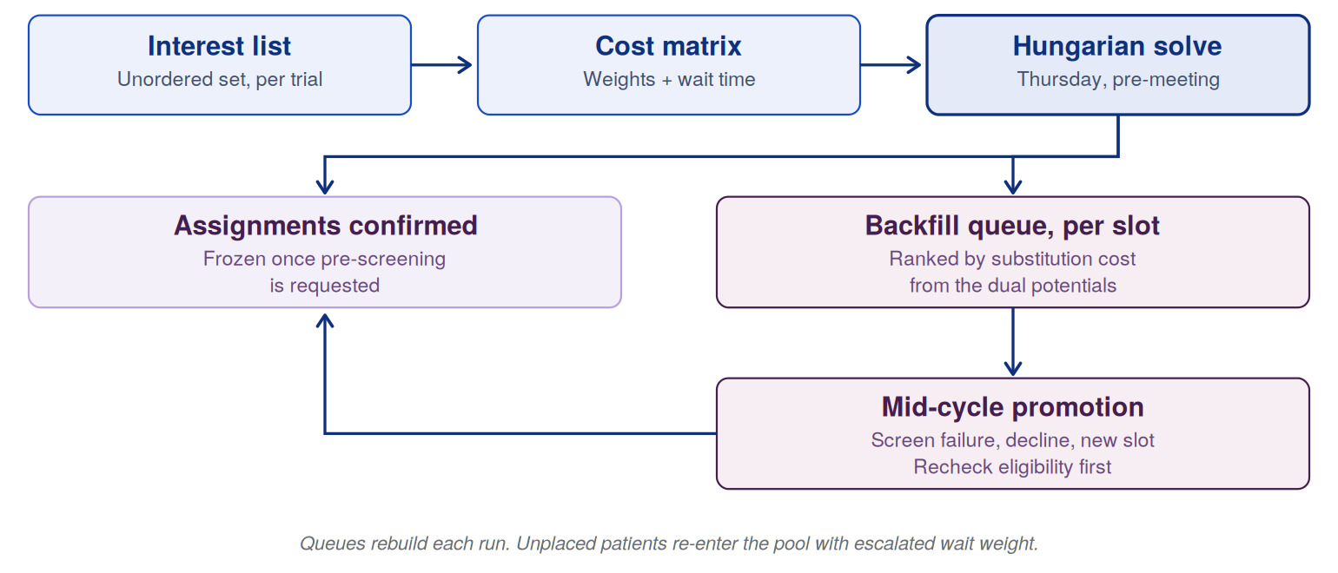

Figure 2. Interest list to backfill queue across one cycle.

Two distinct objects, and only one of them is ordered. Conflating them is what creates the apparent conflict between queueing and optimization.
- Before the run it is a set. Every fluid patient whose ranked choices include a trial belongs to that trial’s interest list. No internal ordering — imposing one recreates first-come-first-served. Its job is counting, which drives the triage above.
- Wait time is a weight, not a sort order. Time in the pool is real clinical information. It belongs in the cost matrix as an escalating term, with a hard ceiling past which a patient is promoted to must-place status.
- The queue comes out of the solve. The Hungarian dual potentials tell us, for each unassigned patient and slot, how much worse that assignment would have been. Ranking by that value gives a principled next-in-line order — the cheapest substitute — at no extra computational cost.
- Between runs it does its work. Screen failure, decline, sponsor release, site activation: capacity opens mid-cycle and the coordinator needs an answer now. Given phase I screen-failure rates this is not an edge case.
- Then it dissolves. Queues rebuild each run; a persisted queue drifts out of sync with capacity and eligibility.
Two requirements: promotion off a queue triggers an eligibility recheck, never an automatic enrollment, since labs age out and ECOG changes; and queue position is coordinator-facing only.

4 Exceptions and oversubscription

A deviation from the physician’s first choice routes to the treating physician — the person who had the original conversation — with the counterfactual attached: what trade was made, and against whom. Override requires a structured reason. That log is governance evidence, weight-calibration data, and our answer when someone asks whether the algorithm overrides doctors.

Phase I screen-failure rates make one-patient-per-slot allocation systematically underfill. Deliberate oversubscription with a waterfall — a designated next-in-line who advances automatically on screen failure rather than waiting for the next batch — converts that loss into accrual. Epic’s Best Practice Advisory layer does not do this at all.

5 Decisions needed

5.1 Measure first. Four numbers from existing accrual data, no code required:
- Deviation rate — how often engine output differs from the physician’s first choice. Near zero means weighting is optional and the engine’s value today is the audit trail; meaningfully nonzero means weights are load-bearing. This is the pivotal number.
- Contention frequency — share of entries hitting the contested lane. Sets expectations for how often the Thursday wait applies at all.
- Backfill fire rate — how often a slot opens mid-cycle. Determines how much engineering the queue deserves.
- Allocation latency as a share of time-to-consent — measured against sponsor confirmation, pre-screening labs, and coverage analysis. If those dominate, batch cadence costs no real time-to-treatment.
5.2 Open design decisions.
Decision | What hangs on it | Owner
Preference weight scale | Fixed rank-to-weight map (1.0 / 0.6 / 0.3) vs. a clinician-entered value. Fixed resists gaming; entered captures real intensity. | Frank + Michael
Non-substitutable flag | Hard exclusion for "choices 2 and 3 are not acceptable," so it is not a soft weight the solver can trade away. | Frank + Michael
Wait-time escalation | Slope of the escalation, plus the ceiling at which a patient becomes must-place. | Frank + Khang
Auto-confirm threshold | How much slack above interest counts as uncontested. Site-configurable, not hardcoded. | Khang
Off-cycle triggers | Which capacity events justify a run outside Thursday, and who can invoke one. | Frank + Michael
Override reason codes | Structured taxonomy. Feeds weight calibration and governance evidence. | Michael
Re-validation scope | Which eligibility criteria are rechecked on promotion off a backfill queue. | Frank + Khang

5.3 Sequence.
- Pull the four metrics in 5.1 from existing accrual data.
- Confirm with Michael the exact event that constitutes freezing — currently pre-screening requested.
- Settle the weighting scheme before Khang builds the cost matrix, since the schema depends on it.
- Build contention triage ahead of the engine itself: highest value, lowest complexity, and it works with any weighting scheme.
- Defer backfill queue engineering until the fire rate is known.
Comments and disagreement welcome, particularly on Part 1 — the rationale is what everything else is derived from.

